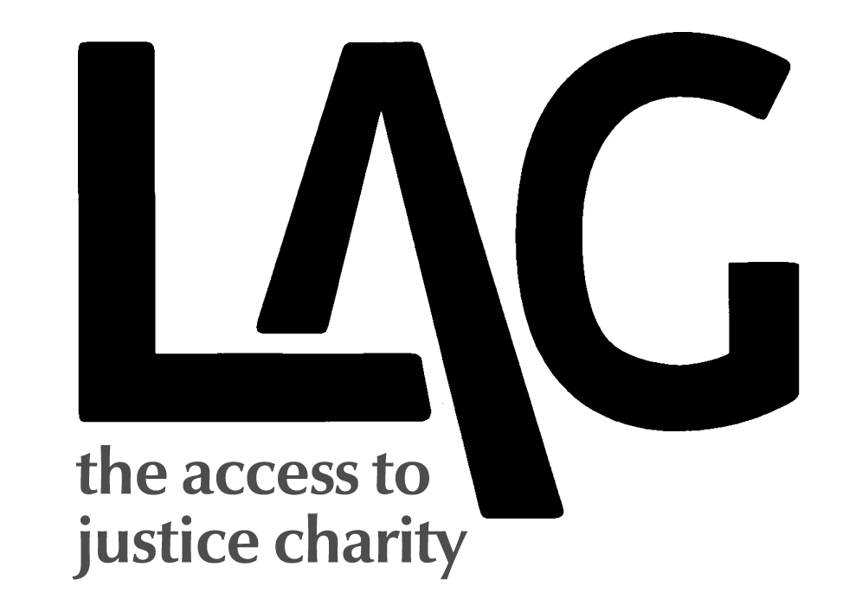

LEGAL ACTION GROUP - PRESS RELEASE

EMBARGOED UNTIL THURSDAY 12.01 a.m 9th JANUARY

LEGAL ACTION GROUP - PRESS RELEASE

EMBARGOED UNTIL THURSDAY 9 JANUARY

Low Commission calls for fresh approach to social welfare law provision after 12-month inquiry

An independent commission, led by cross-bencher Lord Low, is calling for urgent reforms to ensure ordinary people can get the help they need to deal with employment, debt, housing and other social welfare law problems.

The Low Commission was the biggest inquiry of its kind into the impact of cuts in funding for social welfare law advice.

In its report, published today (9 January 2014), the commission calls for a national strategy for advice and legal support, to replace the current piecemeal approach, which is failing to protect the poorest and most vulnerable. It also calls for a £100m implementation fund – with half the money coming from central government, and half raised from other sources, including a levy on payday loan companies.

Other recommendations include:

- Creation of a new, cross-departmental ministerial post, to oversee implementation of the advice and legal support strategy;
- Restoring legal aid for housing cases so people can get help before they face imminent eviction;
- Urgent reform of the ‘safety net provisions’, introduced by the Legal Aid, Sentencing & Punishment of Offenders Act, which are proving unwieldy and unworkable.

Lord Low, who chaired the commission, said:

“Our report makes sobering reading and we are calling on political parties of all stripes to recognise the need to act before we reach crisis point. All around the country we found advice agencies buckling under the strain, and ordinary people left with nowhere to turn.”

Amanda Finlay, commission vice-chair and former legal services strategy director at the Ministry of Justice, said:

“In these days of austerity, we realise hard choices have to be made. But just cutting legal aid is not the answer. The problems still remain. We should follow the example of other countries which have reduced legal aid but recognised that help is still required, and invest in better information, advice and support.”

During its year-long inquiry, the Low Commission heard evidence from around the country:

- Tameside, near Manchester – 5-week wait for appointments at local Citizens Advice Bureau; only 10% of those needing specialist help are able to be referred on (down from 50%);

- Gloucester: housing charity Shelter has closed its office, the CAB has gone into administration; while Gloucester Law Centre is still going, demand for immigration and debt advice has doubled, compared with last year;

- Birmingham: local CAB lost more than half its local authority grant (down from £590,000 to £265,000), plus £700,000 in legal aid funding;

- Sutton: CAB has seen trebling of demand for welfare benefit appeal advice in last three years;

- Swansea & Neath Port Talbot: CAB has had to axe 12 out of 36 staff posts because of 30% cuts in budget.

For more information and to arrange interviews with Lord Low or other commissioners, contact:

Fiona Bawdon: 020 8211 0903; 07740 644474 Fiona.bawdon@blueyonder.co.uk

Steve Hynes (Legal Action Group, director) 07940 776408; 020 7833 7436; shynes@lag.org.uk

Full copies of the report, or an executive summary are available on request. www.lowcommission.org.uk

Notes for editors:

The Low Commission was set up in September 2012 by Legal Action Group, with funding from Baring Foundation, Barrow Cadbury Trust, Esmee Fairbairn Foundation, Llankelly Chase Foundation, Trust for London, and support from Freshfields Bruckhaus Deringer, and Clifford Chance.

Its 10 commissioners were:

Lord Colin Low (cross-bencher) – chair
Amanda Finlay (former legal services strategy director, Ministry of Justice) – vice chair
Bob Chapman (member Committee for Administrative Justice & Tribunals Wales, former acting Wales director of Legal Services Commission)
Prof Mark Gamsu (professor & consultant in public health)
Vandna Gohil (former director Voice4Change and programme manager for Voluntary Action, Leicestershire)
David Hagg (CEO, Stroud District Council)
Steve Hynes (director, Legal Action Group)
Pam Kenworthy (legal director, Howells LLP Telephone Services)
Vicky Ling (former member, Civil Justice Council, author of Legal Aid Handbook)
Susan Steed (New Economics Foundation & Centre for Market & Public Organisation, University of Bristol)

Legal Action Group is a charity dedicated to promoting access to justice. www.lag.org.uk

